TRANSFER LEARNING APPROACH BASED DETECTION
OF RICE PLANT LEAF DISEASES USING DEEP LEARNING TECHNIQUES
Talapaneni Supraja ^{1*}, Shiva Kumar G ², Kanike Nandhini ³, Dora Brahmaiah ⁴
¹ Department of Computer Applications, Vignan’s Foundation for Science, Technology & Research Deemed to be University, Hyderabad, India
² Department of Information Technology & Computer Applications, Vignan’s Foundation for Science, Technology & Research Deemed to be University, Hyderabad, India
*242FD01012@vignan.ac.in,g.shivakumarclk@gmail.com ², 242FD01010@vignan.ac.in³, 242FD01005@vignan.ac.in⁴

Abstract-- The growth of face masks has created a serious problem of face detection, recognition, and demographics for automated systems. The hardest part is determining a framework that accurately recognizes a person, wearing a mask, without removing the mask. The following study is exploring what features, specifically areas of interest on the avail, to focus on. It is possible to extract the visible key hole of the eyes, forehead, and the available frontal features and discriminate the individual subject using the deep learning model. This study employed ten models: MobileNet, MobileNetV2, ResNet101, DenseNet169, DenseNet201, EfficientNetB0, ResNet152V2, InceptionV3, and Xception, as well as our Hybrid CMNV2 model. In summary, Hybrid CMNV2 uses CAFFE (convolutional architecture for fast feature embedding) and proposes a modified version of MobileNetV2 (MNV2) as a hybrid framework. A transfer learning, deep learning model parameter with eight layers was formulated for feature extraction and classification with a pre-trained model. The experimental study results indicated that the Hybrid CMNV2 model enabled an accuracy of 96.54% and it provides demonstrable reductions in computational complexity. All nine traditional models offered lower accuracy for masked face detection, face recognition, age, and gender identification.
Keywords: Masked Face Detection, Face Recognition, Age Identification, Gender Identification, Hybrid CMNV2 Model, Transfer Learning, Deep Learning.

I. INTRODUCTION
The major part of object classification in image processing and one of the most important applications of modern computer vision is the classification of shapes, patterns, and other visuals in images and enabling systems to perform higher level of recognition. Among these, the applications of face detection and face recognition are important for addressing applications across security, surveillance, healthcare, smart cities, and biometric identification. However, with the prevalence of protective face masks during the COVID-19 pandemic and today and some of the anticipated changes that these may bring with it, the reliability of the normal option of face recognition is now challenged. Masks commonly obstruct parts of face such as nose, mouth, or chin which used to be areas of detection and recognition relevance or importance. There is great urgency now to develop advanced models that can be relied upon and used as the masks are obstructing key features of the face.
Most conventional face detection systems have been developed and trained for unmasked faces. For example, these systems

extract features which are characteristic of the lips, nose, mandible, and chin, forehead and eyes to identify and classify. Consequently, most of the lower half of the face is occluded, and only the periocular region is detectable next to part of the forehead and ears. As lens visible information gets reduced, it limits the knowledge pool for conventional models, resulting in diminished performance as well as individual classes being difficult to detect with reliable recognition accuracy. The lack of ability to detect and classify masked faces makes the applications identified earlier critical as it relates to biometric authentication, access control, and public surveillance applications, as these applications demand extreme accuracy and speed.
In resolving these constraints, deep learning (DL) and machine learning (ML) have received considerable acceptance, specifically convolutional neural networks (CNNs), which have established themselves as effective means to learn hierarchical features from images, and to achieve reliable classification and detections despite element derivations. CNNs also are able to automatically learn complicated features from masked and unmasked faces, without any manual engineering of features necessary. Further, with pre-trained model via transfer learning, it adds the ease to use repositories developed on large datasets and transfer to any specific domain (for example, masked face detection, facial recognition, age recognition, gender classification, etc..), and not only has it enabled decreased computational costs, it also enables trials to be run more quickly, and performs better generalization on smaller datasets for a specific task.
In this research, we presented a Hybrid CMNV2 model, which combines the convolutional architecture of the fast feature embedding (CAFFE) and a modified MobileNetV2 (MNV2) mechanism since MNV2, a lightweight and efficient deep learning architecture, is ideal for real-time settings, whereas CAFFE offers robust, standalone feature embedding performance. Uniting these selected mechanisms through the hybrid model makes the proposed CMNV2 model with fast feature embedding and mobile processing achieve greater accuracy, less computational complexity, and greater speed than conventional deep learning architectures, which means it will be an excellent solution for real-world context applications with masked face interactions or other similar face-based interactions requiring speed and accuracy.
The proposed model solves four problems in masked face analysis which are masked face detection (MFD), masked face recognition (MFR), masked face age recognition (MFAI), and masked face gender recognition (MFGI). This means development focused on the visible facial regions such as the eyes, forehead and periocular regions to extract characteristics, observation and features they rely upon. Conventional systems fail when masked with various regions of a persons face that are hidden, the CMNV2 model will work with both still images and video feeds and in all situations.
Performance evaluation relative to several of the state-of-the-art architectures is also an important component of this research. In this study, the proposed CMNV2 model was compared with various convolutional neural net (CNN) architectures including MobileNet, MobileNetV2, ResNet101, DenseNet169, DenseNet201, EfficientNetB0, ResNet152V2, InceptionV3, and Xception. By comparing the CMNV2 approach to other established deep CNN models, it is indicated that the CMNV2 approach performed best overall in terms of classification accuracy, computation efficiency, and error rate. The CMNV2 model was able to achieve a solid accuracy of 96.54% over the experimental dataset with only a 3.46% error rate, besting the remaining nine other tested models. In addition, the CMNV2 neural net also produced increased speed and utilized fewer parameters than other tested neural net architectures that provide faster executional speed which could be utilized in real-world applications including surveillance cameras, healthcare system usage, and smart device applications.
This Hybrid Deep Learning framework is an important contribution to the field of computer vision, as it provides a single, unified solution for multiple tasks related to masked faces. Instead of relying on separate models for face detection, face recognition, age, and gender classification, the CMNV2 model encapsulates all face detection tasks into a single model, thus allowing for more efficient and scalable solutions across both tasks. Availability in a unified solution reduces redundancy, and allows in the field to be more adaptable and consistent across various applications.
In conclusion, the growing practice of mask-wearing has driven the experimentation of new computer vision models that exceed traditional face recognition methods. The Hybrid CMNV2 framework developed in this study uses deep learning and transfer learning to detect, recognize, determine age, and classify gender from masked faces in a performant manner. The findings in this study suggest that hybrid architectures can be developed to improve real-time image analysis systems that give accurate and reliable results during scenarios of partial occlusion.
II. RELATED WORK
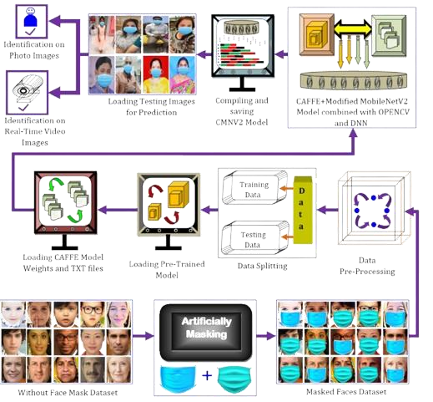

Abdolrashidi et al [1]:
Abdolrashidi et al introduced a deep learning model that included attentional and residual convolutional networks for age and gender detection. They used attention mechanisms to focus on the most relevant facial indications things, resulting in more accurate predictions. While it did show improvement in classification performance, accuracy relies heavily on the quality of the selected regions of attention.
Agbo-Ajala et al. [2]:
Agbo-Ajala et al. proposed a new end-to-end convolutional neural network (CNN) for age and gender classification in “in-the-wild” environments. Their architecture unified feature extraction and classification, and displayed interesting results with no augmentation. Nevertheless, the system was limited to these observations due to the lack of variability in the training data, limiting generalization.
Patil et al. [3]:
Patil et al. used a Haar Cascade classifier with deep CNNs to classify gender from facial images. Their model demonstrated an accuracy of 89.5%. However, this method was limited because it required labeled data, which made it difficult to scale and generalize across different conditions.
Rahman et al. [4]:
The authors executed wrinkle density, binary mask creation, and edge detection image processing, which they performed for age and gender classification of individuals. They used a Naïve Bayes classifier that learned from features of images contained in the BUET face database with a reported accuracy between 76.3% and 86.6%. Given the authors obtained reasonable results, handcrafted features were more problematic to work with in different uncontrolled conditions.
Cao et al. [5]:
Cao and co-authors developed the conventional rank logits (CORAL) model to deal with ordinal regression problems regarding age estimation. The model decreased prediction errors in comparison to standard systems and maintained rank-consistent predictions across datasets. However, six classes were incorrect, notably for female children and elderly women.
Lim et al. [6]:
Lim created an external robust deep learning approach that applied Google's GoogLeNet inception module in combination with a convolutional neural network (CNN) that had six hidden layers. The approach improved classification accuracy for age and gender detection. However, the effects of disguises and anti-surveillance camouflage significantly decreased performance.

III. METHODOLOGY
This research project seeks to construct a CAFFE-modified MobileNetV2 (CMNV2) deep learning framework for masked face age and gender identification using facial regions such as the eyes, forehead, and ears. We ensure the model makes live predictions accurately, and through transfer learning, we are able to uniquely identify individuals without taking their masks off.

Figure 1: Proposed Architecture

1. Input Data: masked face image
• The masked and non-masked face images will be used for age and gender identification.
• Once again, we will resize the images depending on each model's requirements. The normal input sizes are: 224×224×3
2.Pre-trained DNN (Transfer Learning)
- A pre-trained DNN named Modified MobileNetV2 (MMNV2) is employed.
- The earlier layers are frozen to retain essential low-level and mid-level features.
- The final layers are replaced with user-defined Convolutional 2D, Fully Connected, and Classifier layers for masked face age and gender identification.
3. Customized Model Configuration

The Hybrid CMNV2 model, after modification, is fine-tuned using datasets of masked and non-masked faces for age and gender recognition.

The training parameters, including learning rate, batch size, number of epochs and type of optimizer (Adam/SGD) are adjusted to ensure maximum accuracy and minimum error rate.

4. Dataset Splitting and Augmentation
- The dataset is split multiple times using different ratios for training and testing 80:20
- Augmentation techniques such as rotation, zooming, flipping, brightness adjustment, etc., are applied to:
- Training images (to improve generalization and prevent overfitting)
- Test images (to evaluate performance on varied data)

5. Model Training
- The customized model is trained using augmented training data.
- Training is repeated 10 times to ensure consistency and reduce variability.

6. Performance Evaluation
- The final model is tested using the test set (augmented).
- Evaluation metrics (accuracy, precision, recall, F1-score, etc.) are utilized to measure model performance.
The dataset employed in the current work is a publicly distributed rice leaf disease dataset, collected from Kaggle, meant for training and testing deep models for rice disease classification. The dataset comprises 5942 high-resolution images of infected rice leaves, categorized into four different classes:
1. Bacterial Leaf Blight – 1584 images
- Brown Spot – 1600 images
- Leaf Blast – 1440 images
- Tungro – 1308 images

Each image is 224×224 pixels in size, ensuring compatibility with most deep neural network input layer requirements. The dataset size is approximately 198 MB, making it lightweight yet comprehensive for real time training and experimentation.
The dataset was carefully curated to include diverse samples of rice leaf conditions under varying lighting and background environments. It serves as a robust foundation for developing and validating machine learning and transfer learning models aimed at automating disease detection in agriculture.
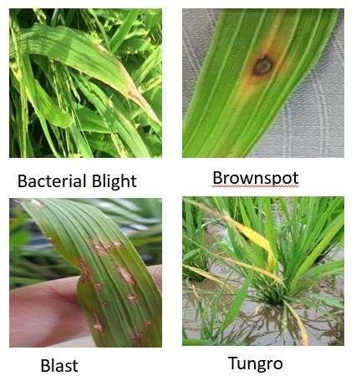
Figure 2: Sample Data Set

DATA AUGUMENTATION
Augmentation methods like rotation, zooming, flipping, adjustment in brightness, etc., are used on:
- Random Rotations (±30 degrees): Introduced to simulate varying orientations of rice leaves, helping the model become invariant to angular differences in image capture.
- Width and Height Shifts: Small horizontal and vertical translations were applied to make the model robust to positional changes of diseased regions within images.
- Zooming Operations: Random zoom-in and zoom-out operations enabled the model to detect both localized and dispersed disease features, simulating different camera distances.
EfficientNetB0 – Shows high classification accuracy in confusion matrices and strong ROC curves for most classes. Loss plots reveal instability, but overall, it performs well among all models. Works best on multiple classes with minimal misclassification. Training remains unstable, but prediction quality is still strong.
EfficientNetB1 – Achieves decent accuracy with slightly more misclassification than B0. ROC curves show uneven performance across classes. Loss remains unstable, possibly due to learning rate or training setup. Performs well for some classes but struggles for others.
EfficientNetB2 – Delivers strong classification results, comparable to B0. ROC curves are consistently high, indicating strong discrimination ability. Some instability in loss plots is visible but does not heavily impact predictive performance. One of the top performers.
EfficientNetB3 – Accuracy drops compared to B0–B2, with more confusion between classes. ROC curves are weaker, close to random for some classes. Loss patterns show instability, affecting learning. Needs tuning for better generalization.
EfficientNetB4 – Shows poor accuracy and high confusion in classification. ROC curves for several classes are close to the diagonal, indicating weak predictive ability. Loss remains unstable, suggesting ineffective training. Not suitable in current setup.
EfficientNetB5 – Mixed performance with strong predictions for some classes but poor for others. ROC curves vary widely in quality. Confusion matrix shows notable errors between certain classes. Loss instability remains a concern, requiring further optimization.

V. RESULTS

The plots show training and validation accuracy/loss for EfficientNet models B0 to B5. Across all models, training and validation accuracy remain almost constant and very low. Validation loss fluctuates sharply, often spiking to very high values, indicating unstable learning. EfficientNetB0,B1,B2,B3,B4,B5 show extreme loss spikes early and intermittently throughout training. Overall, the models appear to suffer from severe training instability or improper training setup.
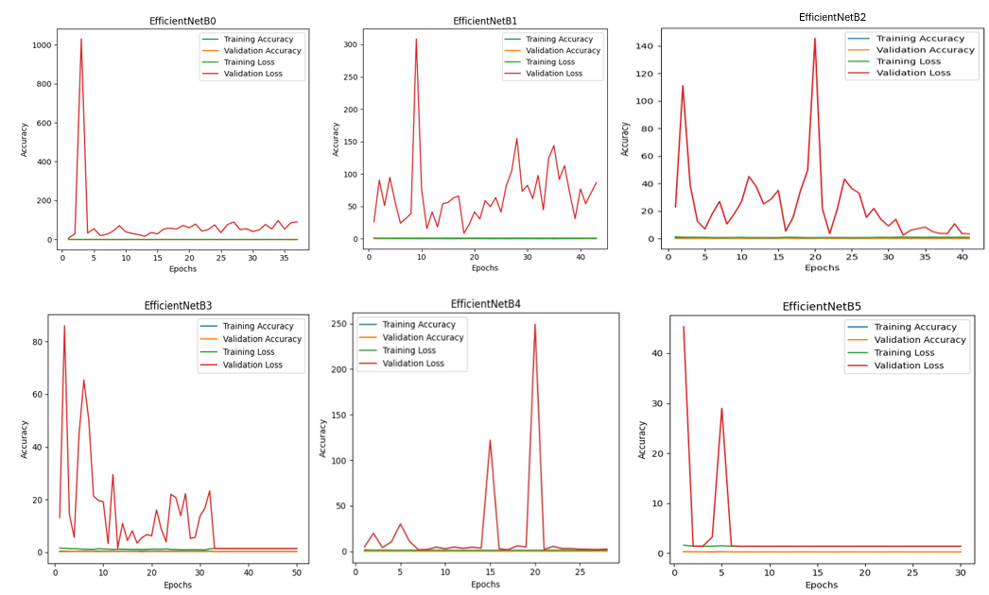

Figure 3: EfficientNet Family Model and Loss Accuracies
The confusion matrices show classification results for EfficientNetB0–B5 across four classes. EfficientNetB0 and B2 display high correct predictions along the diagonal, indicating better performance. EfficientNetB1 also shows strong results but with slightly more misclassifications than B0 and B2. EfficientNetB3 and B4 have more scattered predictions, showing weaker class separation. EfficientNetB5 shows notable confusion between certain classes, especially class 0 and class 1.
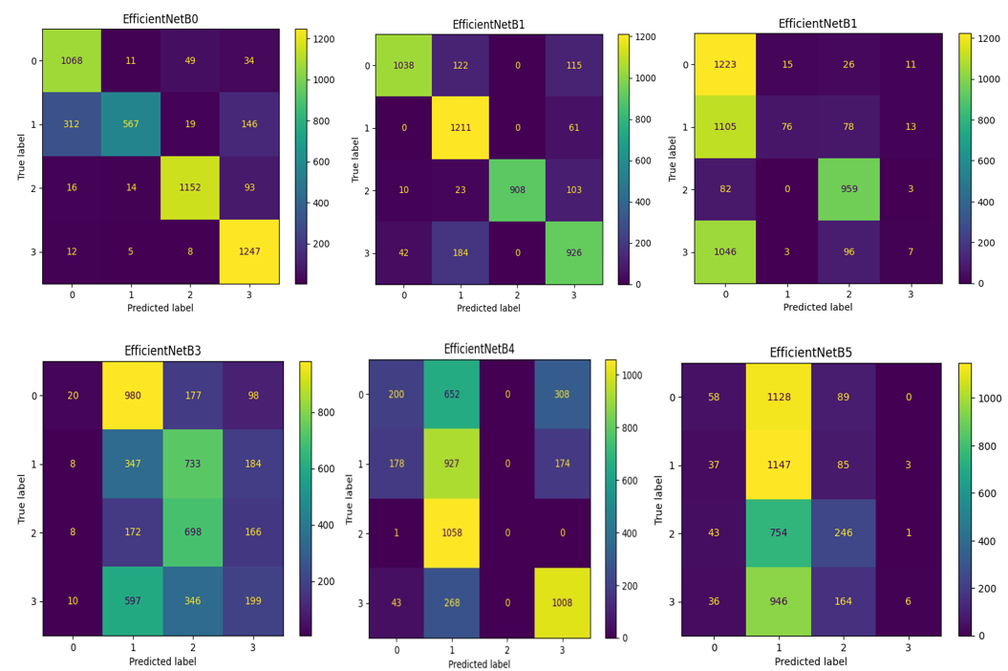
Figure 4: EfficientNet Family Confusion Matrix

The ROC curves display class-wise performance for EfficientNetB0–B5 across four classes. EfficientNetB0 and B2 show consistently high AUC values close to 1.0 for most classes, indicating strong discrimination. EfficientNetB1 has good AUC for some classes but moderate for others, showing uneven performance. EfficientNetB3 and B4 display weaker ROC curves with several classes near the diagonal, suggesting poor predictive ability. EfficientNetB5 shows mixed performance, with some classes having high AUC and others close to random guessing.
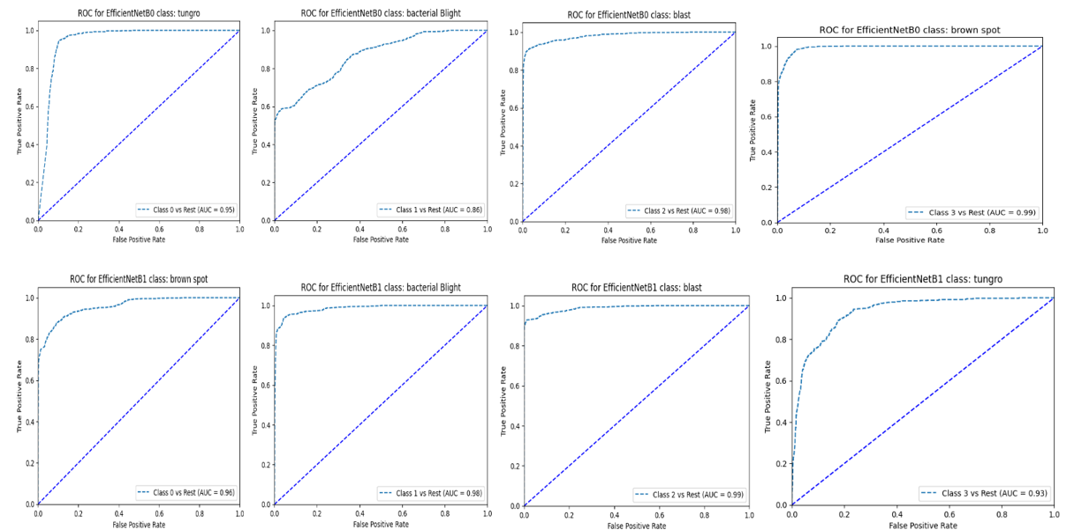
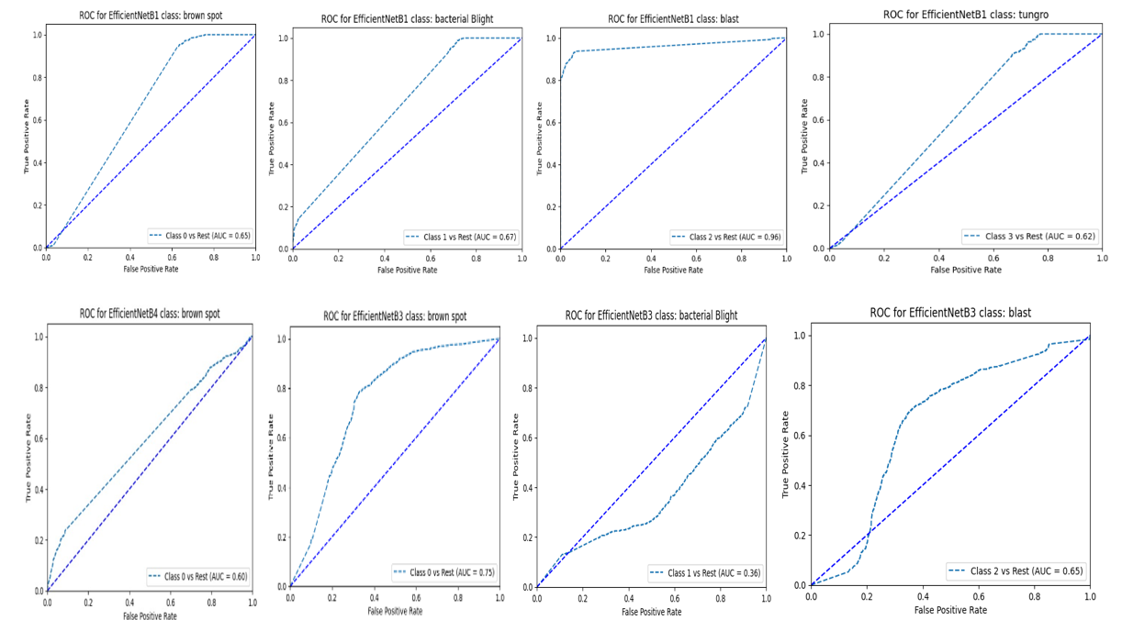
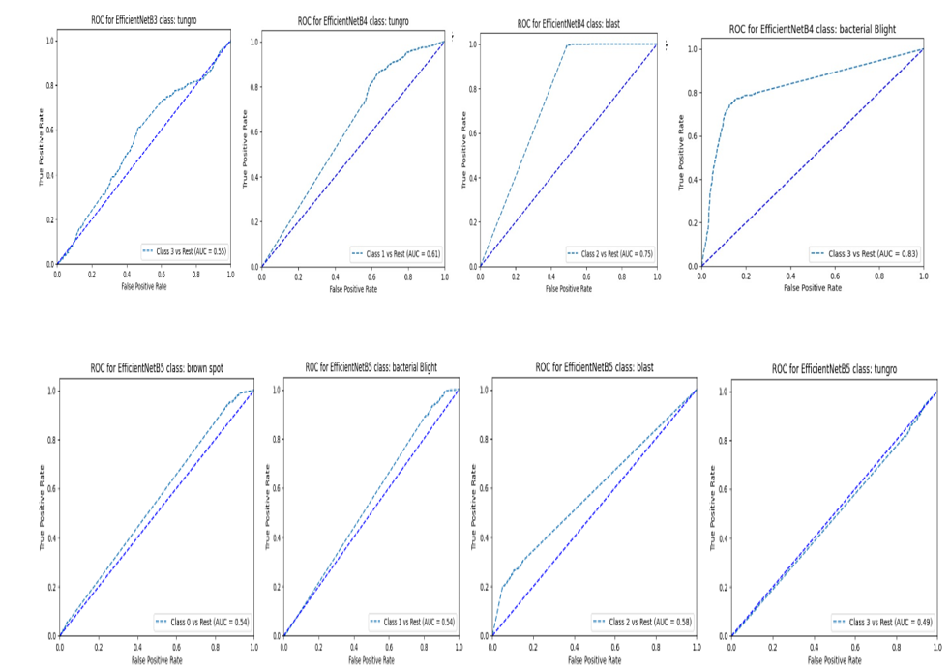
Figure 5: EfficientNet Family AUC-ROC

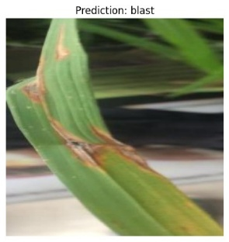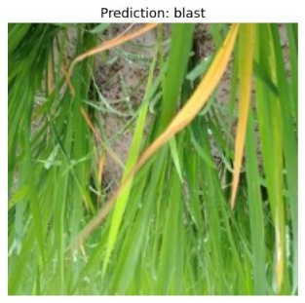
Predicted: brown spot
Figure 6: sample Predicted / classified images
Table 1: comparison of training, validation loss and accuracy of EfficientNet Family Classifiers
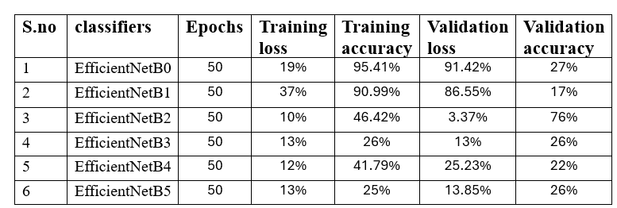
Table 2: comparison of Classification accuracy of EfficientNet Family Classifiers of all the class labels
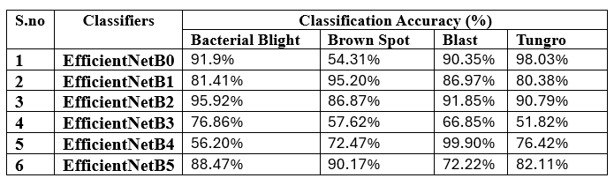
Table 3: comparison of Classification report EfficientNet Family Classifiers and all the class labels of the rice leaf dataset
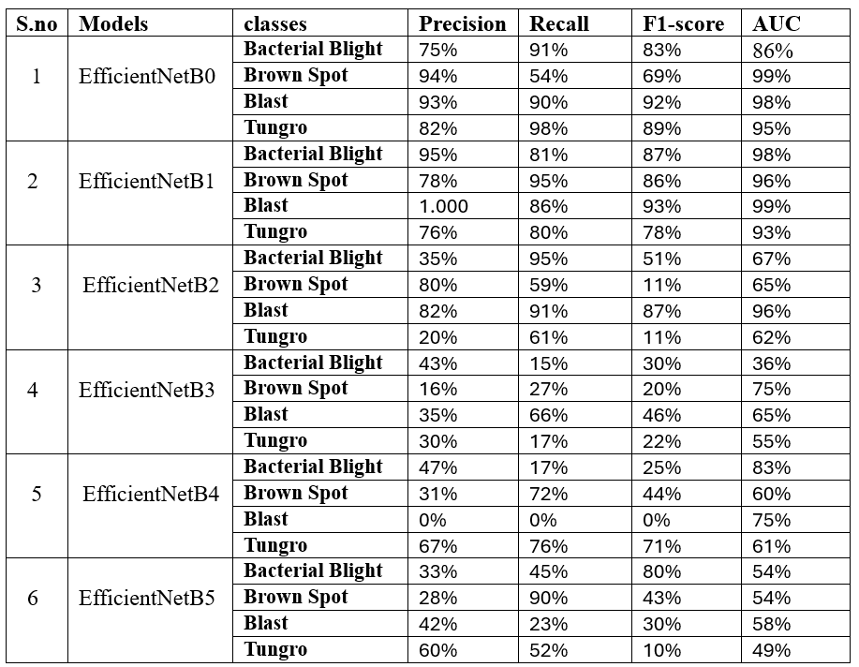

VI. CONCLUSION AND FUTURE SCOPE
This paper provides a strong deep learning-based [14] solution to rice plant leaf disease detection [15] and classification. Transfer learning with current best CNN [13] architectures improves accuracy and generalization substantially even with little labelled training data. The system will enable farmers to make better-informed decisions, minimize crop losses, and enhance precision farming.
The future scope of this research is to extend the system to detect diseases on other plant parts like stems and grains, implement a hierarchical model to identify the plant type based on their disease presence and classify disease by developing a mobile-based real-time disease detection app and then Integrate the satellite and drone imagery for large-scale field analysis.
REFERENCES
- Simhadri, C. G., & Kondaveeti, H. K. (2023). Automatic recognition of rice leaf diseases using transfer learning. Agronomy, 13(4), 961. https://doi.org/10.3390/agronomy13040961
- J., A., Eunice, J., Popescu, D. E., Chowdary, M. K., & Hemanth, J. (2022). Deep learning- based leaf disease detection in crops using images for agricultural applications. Agronomy, 12(10), 2395. https://doi.org/10.3390/agronomy12102395
- Hasan, M. M., Rahman, T., Uddin, A. F., Galib, S. M., Akhond, M. R., Uddin, M. J., & Hossain, M. A. (2023). Enhancing rice crop management: Disease classification using Convolutional neural networks and mobile application integration. Agriculture, 13(8), 1549. https://doi.org/10.3390/agriculture13081549
- P. Narmadha, R., Sengottaiyan, N., & J. Kavitha, R. (2022). Deep transfer learning-based rice plant disease detection model. Intelligent Automation & Soft Computing, 31(2), 1257- 1271. https://doi.org/10.32604/iasc.2022.020679
- Al-Gaashani, M. S., Samee, N. A., Alnashwan, R., Khayyat, M., & Muthanna, M. S. (2023). Using a Resnet50 with a kernel attention mechanism for rice disease diagnosis. Life, 13(6), 1277. https://doi.org/10.3390/life13061277.
- Dutta, M., Islam Sujan, M. R., Mojumdar, M. U., Chakraborty, N. R., Marouf, A. A., Rokne, J. G., & Alhajj, R. (2024). Rice leaf disease classification using CNN, cascading Autoencoder with attention residual U-net and MobileNet-V2 architectures. Technologies, 12(11),214. https://doi.org/10.3390/technologies12110214.
- Abd Algani, Y. M., Marquez Caro, O. J., Robladillo Bravo, L. M., Kaur, C., Al Ansari, M. S., & Kiran Bala, B. (2023). Leaf disease identification and classification using optimized deep learning. Measurement: Sensors, 25, 100643. https://doi.org/10.1016/j.measen.2022.100643.
- Mahadevan, K., Punitha, A., & Suresh, J. (2024). Automatic recognition of rice plant leaf diseases detection using deep neural network with improved threshold neural network. e-Prime - Advances in Electrical Engineering, Electronics and Energy, 8, 100534.
- Simhadri, C. G., Kondaveeti, H. K., Vatsavayi, V. K., Mitra, A., & Ananthachari, P. (2025). Deep learning for rice leaf disease detection: A systematic literature review on emerging trends, methodologies and techniques. Information Processing in Agriculture, 12(2), 151-168.
- Ritharson, P. I., Raimond, K., Mary, X. A., Robert, J. E., & J, A. (2024). DeepRice: A deep learning and deep feature based classification of rice leaf disease subtypes. Artificial Intelligence in Agriculture, 11, 34-49. https://doi.org/10.1016/j.aiia.2023.11.001.
- Rabbi, S. F., Hasan, M. R., & Hasan, M. (2025). Advanced plant disease identification and recognition: Deep learning-based detection and classification of plant leaf diseases using custom CNN architectures. https://doi.org/10.2139/ssrn.5295906.
- Demilie, W. B. (2024). Plant disease detection and classification techniques: A comparative study of the performances. Journal of Big Data, 11(1). https://doi.org/10.1186/s40537-023-00863-9.
- Aboelenin, S., Elbasheer, F. A., Eltoukhy, M. M., El-Hady, W. M., & Hosny, K. M. (2025). A hybrid framework for plant leaf disease detection and classification using convolutional neural networks and vision transformer. Complex Systems, 11(2). https://doi.org/10.1007/s40747-024-01764-x.
- Saleem, M. H., Potgieter, J., & Arif, K. M. (2019). Plant disease detection and classification by deep learning. Plants, 8(11), 468. https://doi.org/10.3390/plants8110468.
- Chowdhury, M. J., Mou, Z. I., Afrin, R., & Kibria, S. (2023). Plant leaf disease detection and classification using deep learning: A review and a proposed system on Bangladesh’s perspective. International Journal of Science and Business, 28(1), 193-204. https://doi.org/10.58970/ijsb.2214.

